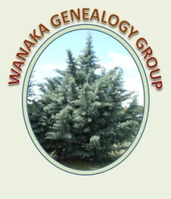
WANAKA GENEALOGICAL GROUP
MARCH 2022
Hi all
We hope you are all riding the Omicron Wave safely. Hopefully, when it passes, we will get back to running normal meetings again. We have held our last three meetings at Louises house – thanks Louise – with windows open and mask wearing.

Our Annual General Meeting is coming up in May so now is a good time for you to think about ways you can offer support.

This has turned into a rather large Newsletter – we hope you find plenty of interest to read in it.

Our next meeting, on Friday 25 March, is a trip to Bendigo where Ken Thomlinson will talk about the Gold Fields there. Could you let Lesly know if you are going and also if you need a lift – email - graham.lesly-stewart@xtra.co.nz phone – 443 7254. A reminder notice will be sent out again next week with a change of day if needed because of weather conditions.

Ken has provided the following outline:

We will meet at 11am at Bendigo Creek at the bottom of the hill to talk about the discovery of gold in the Lindis River in 1861 and in Bendigo Creek in 1862. We will then drive up to Logantown, named after Thoms Logan who discovered the gold-bearing quartz reef and made a fortune from it, but died in “poverty” – or did he? It then is a short drive to Welshtown where we will have our lunch.

There is very little shade so you should have sun protection (hat and/or umbrella) and plenty of water. There is a DOC toilet.

After lunch I will talk about gold mineralisation and have some maps and diagrams to explain quartz reef mining and the history of the companies and people involved.

We will then take a loop walk through the workings and should be back to the cars by 3 o’clock. The track is a bit rough in places so you should have good walking shoes

PHOTOBOOKS for FAMILY HISTORY
Photobooks are primarily for photos so if you have a lot of text this is not the medium that works best.

 | PowerPoint | Diamond Photo diamondphoto.co.nz | MixBook  Mixbook.com.au
General comments | Versatile  Can be easily amended | NZ  Reasonably priced  Free delivery at the moment. Needs careful planning | Australian  Most expensive but very user friendly.
Templates | Limited | Nothing specific for family history | Lots of choice  Family History category
Layout | Simple  More options for text | If you change the layout after adding photos it takes away everything (background and photos) | Easy to change, swap photos. Keeps background
Upload of photos | Not necessary as not online | Bit tedious and slow | Can upload a folder of photos  Much quicker
Price | Cost of paper and printing at home or library | Most reasonable, especially with an offer | Most expensive
 |  | Quick turnaround | 1-2 business days

PLAN
All of them need a plan so you can determine the size of the book needed.
Good preparation will save you a lot of time

PHOTOS
Decide which photos you are going to use. Is the quality good enough?
What else can you use? - Newspaper articles, certificates, charts
Create a folder for your photobook images
TEXT
Some of the templates don’t provide much space for text but you can add text boxes and delete photo placements
LAYOUT
If you want to add certificates and family trees, go for Landscape.
EMBELLISHMENTS
BACKGROUND
Diamond Photo
- Look at Offers. The current offers end at midnight on 31 March 2022. There are always more coming so if you miss one, look again
You don’t have to buy the voucher before you create the book but if you do make sure to leave enough time to create your book.
- Look at photobooks and choose from different covers, sizes, page numbers. This is why you need an idea of what you want to create.
- Themes. None with much space for text. Works well if you have a lot of photos and want just titles
- You can create your own style.
- Upload photos
First add Layout. (If you do Background first the layout will take away the background)
Text – Click on “Add text” It appears, quite small in the middle. Drag to where you want it and change size, colour, type
Add Embellishment – click on it to resize
Background – Do this Last. All Pages or This Page.
If you change the layout now it will take away everything on the page

Mixbook
Click on PhotoBooks at top. Scroll down to “How it Works”
Start with square, portrait or landscape
Scroll down – deals are mentioned if there is one or look at deals separately
Browse Landscape – scroll down to Remembrance and Family History
Our Family Lineage – Click on “Quick Preview” to check it’s what you want
Photos – import new ones or use from another project. You can import a folder at the same time.
Add text. Drag the text box to where you want it. Very easy.
Add background – use search to find a suitable one
Try another layout – doesn’t change background. You can make any changes to the layout of the page and your information remains.

There is a good article on Photobooks, including Mixbook in the WDYTYA Magazine, available for members to borrow.
Lost Cousins Newsletter
Ken Allan drew our attention to the following article in Lost Cousins Newsletter that you may be interested in:

Ancestry add photo-scanning and retouching to their app
I suspect that, like me, most of you do your family history research using a web browser (like Edge or Chrome), running on a computer or tablet. But it seems the younger generation, with their better eyesight and dexterity, are more likely to use an app on a smartphone – something I'd never seriously considered until now.
At RootsTech yesterday evening (London time) Ancestry announced a collaboration with a
and much, much more including:
Auto-detect image boundaries and auto-crop photos
- Scan multiple images from one page and split into individual images
- Enhance and restore the quality of images
Until now converting family photo albums into digital images has, frankly, been quite a chore. In fact, so much of a chore that I've only scanned a small fraction of my own collection, which has thousands of photos across dozens of albums. So even I might be tempted to start using the app, which until now has been sitting unused on my phone.
Note: on Photomyne's own website they talk about scanning in 100 photos in 10 minutes!
You can find out more in this Ancestry blog post.

DNA MEETING - 25 January 2022
Are you getting the most out of your DNA Results.’ Plus “Any new discoveries to report’.

Tasks to carry out before the meeting were:
1 If they haven’t already done so, to start entering their family tree into their DNA programme or transfer one they have, using GEDCOM.
2. Use the triangulation method to assign Matches to particular branches of their tree. Colour codes can then be used to identify different branches
3. Check out most recent matches and see who they match with.

After a rocky start when the computers wouldn’t talk to each other, Margaret was able to explain verbally some of the suggestions she had for enhancing results from DNA tests and the members present reported on results they had got using the tasks above or reported on new exciting DNA discoveries they had made. Four were willing to share their discoveries with you. Two of these stories mentioned DNAPainter. Ken Allan has found it particularly useful so this might be a topic for a future DNA meeting.

The following three stories relate to making connections in families where illegitimacy has occurred:

Joan Byrne

I have had my DNA tested with Ancestry and I have also uploaded the data to My Heritage.
Once your results are received you can look up your DNA matches and then it was suggested that we perform triangulation. That means selecting yourself and one of your matches and then you will be given a list of common ancestors. This is a great help as you can then classify them into either the paternal or maternal line of your tree and there is an option to place a colour coded dot beside them for future reference and make a note of their relationship to you.
It can also throw up some mysteries – I emailed a shared match nearly two years ago and initially there did not seem to be a connection. Out of the blue he has emailed me again in the last couple of weeks saying that he has had to redo the paternal side of his tree because his father (that he thought) is not his father and through shared matches there is a link with someone who is his new first cousin. I still can’t find a connection but who knows there must be something way back in the past!!

Another option on Ancestry DNA is to go to ThruLines – this gives you a list of ancestors in your tree and how many DNA matches there are to them. Click on the selected ancestor and this will give a list of descendants from other people’s trees – just be careful that any data you load has been sourced.
Other suggestions at the meeting were to use DNA Painter and WATO but I haven’t had a chance to try these yet.

Thank you for an informative meeting.

Sue Evans

Times have changed, but Grandma, born in Glasgow 1900 had “illegitimate” written on her birth certificate, a shame she carried with her all her life.

Her daughter, my Aunty Dot had her DNA done, I had my DNA done.

A DNA Match made contact but he was confused as to how we were related as no names matched up. Even after the Scottish ancestry and relationships were detailed as ‘1st cousin twice removed - 2nd cousin once removed’, there were no clear paths to our match.

My Heritage announced DNA Match quality: 2.5% (179.1‎ cM)Shared DNA
6 Shared segments. 82‎ cM and 394 DNA matches.

I emailed back and explained Grandma’s situation and he was then able to deduce, from DNA matches confirming age and birth locations, who Grandmas probable father was (down to one of two brothers!)

A chromosome browser check told us that we had 4 triangulated segments in common. I was convinced and happy to confirm his probable deduction as correct when my Dunedin born first cousin also became part of the shared data.

Would Grandma or her children be any happier for the knowledge?
Her favourite Granddaughter is!

Ken Allan
I have been searching for my sister-in-law’s father for a number of years and will briefly explain how I am now 90%+ sure I have found him.
First step was using triangulation using DNA results from the sister-in-law (let’s call her Jane) and being able to identify a number of DNA matches from what had to be Jane’s father’s line. A bit of luck was involved, as in almost every case DNA matches replied to emails and I was able to create a family tree combining them all (but did not know where to put Jane!). But at least 5 DNA matches were in the tree and all originated from the one area in NZ where Jane was born.

The next step was to go to DNAPainter (https://dnapainter.com) where I discovered a Tool called WATO (What re the odds?) Version 2. In short, after downloading a Gedcom file of the Tree to WATO, the program calculated the odds of each person in the tree being Jane’s father. Naturally the tree included people who could not possibly be Jane’s father so an exercise in elimination followed (research was needed). For example, men who were clearly never anywhere near the town where Jane was conceived, ones who were deceased at the time etc etc were eliminated.

The best result was from three brothers. One predeceased the conception, one lived in another island and was married and hundreds of km away, so maybe unlikely, and the last one was single, living with his mother and lived 400m away from Jane’s natural mother. What are the odds????

Unfortunately there were no descendants of these three brothers (other than possibly Jane) so there is no one to get a DNA test from that might finally prove if the most likely brother was Jane’s father. The whole exercise took well over 9 months but without it, Jane would not have discovered who her Father might be, nor a lot of new cousins! Warning – lots of patience required!

Marie Latta’s Findlaters:
I have known about the NZ Findlater’s for some time and I was surprised when my DNA results come up with Irish Findlater’s, It turns out that John Findlater and myself both have great grandfathers who were brothers. John Findlater lives in Dublin and his nephew Dermott Judge (Cork) has also been in touch wishing he had come to NZ when he had a trip to Australia, at the time he was not into genealogy and didn’t realise how many Findlater's there were in NZ. John has also given me Findlater information back to 1617.Thank you to the members who gave me help with early marriage records.

The last story relates back to a family in the late 17th early 18th century and how a change in circumstances can change outcomes for family members – just as relevant today.:

Margaret Thomlinson:
While researching “Unviewed” matches for the DNA Meeting I came across Jim, a 4xCousin-once-removed. Jim had submitted a large family tree and as I had recently purchased a six-month subscription to Ancestry I was able to go back far enough to see that he was descended from my 4xGGrandparents Gray and Sarah Blandford through their daughter Ann. ‘Through Lines’ showed five further DNA matches that also descended from Ann. I contacted Jim and shared my Blandford information with him

As often happens this led to me sideways to another Blandford contact, my 5xCousin-once-removed Bob. He had offered to share more of his family line’s history with me when we corresponded back in 2018 and I hadn’t followed up on that. Bob, Jim and I descend from Jasper and Ann Blan(d)ford. Unfortunately, Bob hasn’t shown up in DNA Matches since Ancestry removed more distant matches.

Bob replied with information on a noteworthy member on his Blanford family line that led me to further explore the lives of Jasper and Ann Blanford and their family. I will come back to Bob’s information later.

Jasper Blanford was born 20 February 1718 in Semley Wiltshire. In 1752 he was living in Wokingham Berkshire and advertising the services of the Wokingham Carrier carrying ‘goods and passengers at the most reasonable rates. Performed if God permits by Jasper Blanford.” About that time, he married Sarah and they had a son William in 1754. William was later apprenticed to a George Field, Draper in Wokingham. You may be interested to read the terms for an apprenticeship in those days:

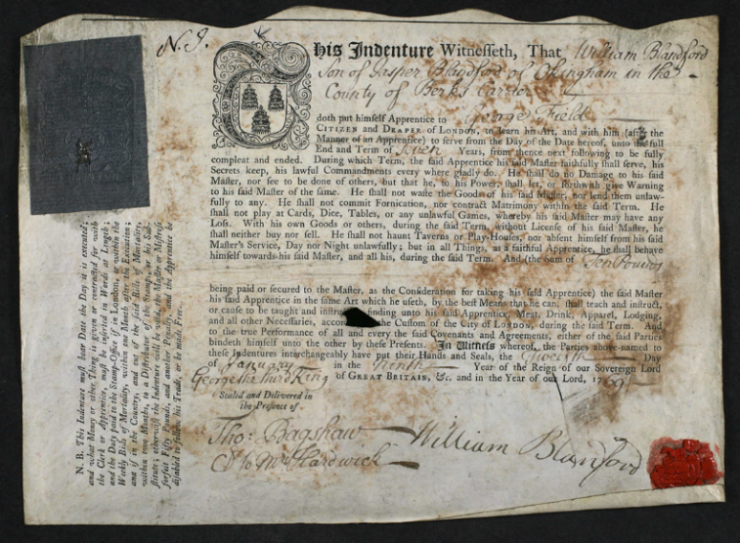

Sarah died in 1758 and in 1759 Jasper married Ann Stapely.

Jasper and Ann had 13 children seven of whom died as infants, the last two in 1775, James in June and the third child named Jasper on 4 July – the same day as his father.

These Records suggest that life had been sad but not necessarily difficult for Jasper and Ann. Jasper had his business and his first-born son William was in an apprenticeship.

Jasper and Sara’s first son and child Stapely was also working in an apprenticeship, with John Miller a Bookbinder, in 1774 the year before Jasper’s death. Later in 1787 he married Hannah Webb - I found the following two documents relating to their marriage intriguing.

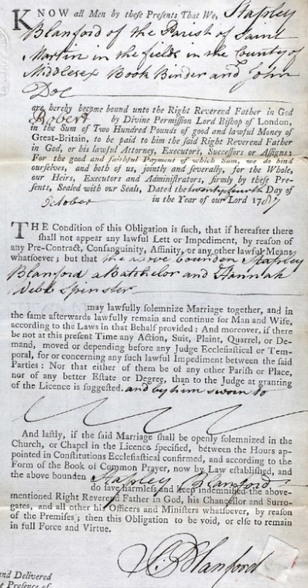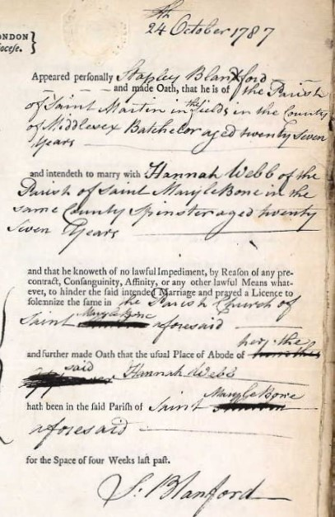
Stapely appears to have gone on to work in the trade as he is listed as a Copper-plate printer at Kings Head Court in 1793 and was paying £4 rent there from 1797 to 1804.
Though Jasper’s will bequeaths her all his stock in trade and furniture etc life will have changed for the worse for Ann and her six remaining children. Stapeley the oldest was aged fifteen and the youngest just three years old. Two bits of information would seem to confirm that.

In 1776 14-year-old Thomas, Bob’s 4xGGrandfather was apprenticed to Richard Wynn, Watchmaker through a Laude Charity. These were only given to the very poor in Wokingham. A younger brother George also benefitted from a Laude Charity and was apprenticed to the same Richard Wynn, Watchmaker in 1783. Both brothers and their descendants carried on successfully in the watchmaking business, Bob’s family for 150 years.

Bob’s 2x Great Grandad William Blanford, who had emigrated to Aurora Illinois, US, made the following famous astronomical clock. To read about this clock open
https://kanecountyconnects.com/2019/01/kane-county-history-blanfords-astronomical-clock-is-auroras-most-astonishing-treasure/

I will attach part of a letter William later wrote home describing how he made his clock for those of you interested. I was also surprised to find an Obituary for William in the Southland Times 27 July 1920 that you could also follow up in Papers Past New Zealand.

In a later email Bob passed on web sites for two further interesting Blanfords in our family:
William Thomas Blanford and his brother Henry Francis Blanford. See links below:
https://en.wikipedia.org/wiki/William_Thomas_Blanford
https://en.wikipedia.org/wiki/Henry_Francis_Blanford

The other bit of information suggesting family difficulties relates to my 3xGGrandad Gray. He was a year older than George but does not seem to have had the same opportunity offered. In 1786 he was convicted in the old Baily for stealing ½ lb stone blue (used to whiten washing – a mixture of synthetic aquamarine and washing soda) and sentenced to 7yrs in the hulks. At the trial Gray’s statement gave an insight into his mother’s plight –
‘I am out of work at present, I live with my mother; she is out a nursing a young woman in Wine-office-court, Fleet-street, and she washes for several of us; she has six of us to maintain, and she told me sometime in the day to get her some blue, and she gave me a shilling; I bought it at a grocer's facing Woodstreet, Cheapside; I do not know his name.’ – this was unfortunately a fib!!

While researching for this story I came on an interesting fact. Kings Head court where Stapely Blanford had his business was hard by Wine-office-court where Ann was visiting on the day Gray was apprehended.

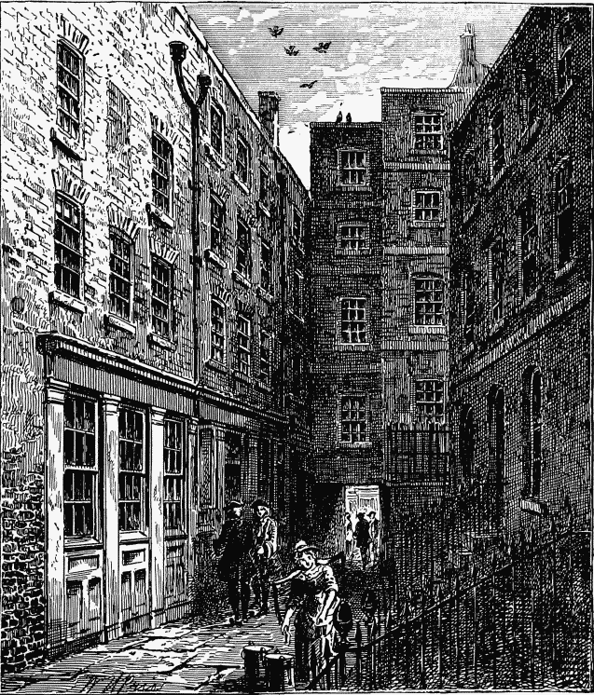
Wine- office-court
Gray apparently served the first six months of his sentence in Newgate Prison as the Hulks were full – transport to America had stopped and hadn’t yet begun to Australia. There is no information at present where he served the rest of his time – or even if he did - but he later became a sawyer and married Frances Fitch in 1796.

Those of Gray and Sarah’s family I have found records for appear to have worked in more manual jobs. My 2xGrandad, Thomas Blandford was a carman in London – ‘A very old trade - employed in driving or taking charge of vehicles which carry merchandise. A Livery Company was established in the City of London in medieval times. By the nineteenth century the trade of carman was largely unregulated’ and conditions of work unpleasant and poorly paid. His brother James emigrated to New Zealand in the late 1870s later in his life with several of his family and their families, There was apparently a story that he was a remittance man – maybe his more successful relatives helped his family make this move!

REMEMBERING OUR FIRST HOME - 25 February 2022
We had a very interesting meeting, at Louises home, sharing memories and photos of the first home we lived in – or remember. There has been a great response to a request to record those memories for you all to share. These stories start in Wales and end in Queenstown. A great piece of Social History:

Kay Seyb :

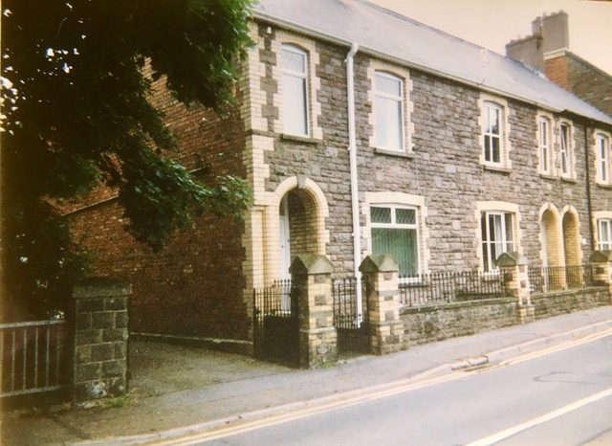
Abergavenny

I was probably about two when we shifted to Abergavenny at 2 Mill Road - now named Stryd y Mynach Isaf, (Lower Monk Street) - leading to what used to be Pen-y-fai Psychiatric Hospital. The house was at the bottom of a hill next to a stream. At the time the row houses had been numbered 1,2,3, etc up one side of the road. We were number 2 as number one had been washed away by a big flood soon after our move. My parents would often point out the water mark at adult shoulder height on the wall in the front room. We were lucky as what remained of no. 1 was demolished and this allowed us to have a garage and a tiny sun room, plus a paved side garden where I could play.

It was a typical house of its time. Built as accommodation for workers. The front door lead into a small hallway with a stairwell on the left with a door on the right which in turn led to the rarely used front room. Further along the passageway was the “living room”. The room had a coal range where all the cooking was done and where we had our weekly baths on a Sunday evening. The tin bath would be placed in front of the coal range where the water was heated. After which we would be sent to bed and presumably my parents had their turn. Probably in the same water!

This is where I spent most of my time. It was a fairly dark room with only one window, on the back left corner. There was a small table which was covered with the green, victorian, tasseled cloth that had belonged to my grandmother Nellie. I would spend hours under that table talking to my rag doll. She was my only soft toy so we were very attached. And I certainly wasn’t impressed when the Christmas I was three she was whisked away by some character called Father Christmas and replaced by a small panda !! The result was that the panda was left on a swing at a park. Never to be seen again. Probably picked up by a more deserving child. Accompanying the table there were four chairs. These had been made by one of my mother’s ancestors a few generations earlier and refurbished as they were passed down the line.

Beyond that was a small scullery where the dishes were washed and meals prepared. An outside door led to a toilet and coal shed.

The rest of furniture in the house was fairly basic. Most of it, like the leather lounge suit in the front room, had been inherited by my mother. I don’t remember there being any wardrobes, just some small chests of draws and my father’s army trunk. My brother was the lucky one as he had a thick traditional Welsh woollen bed cover that had graced my mother’s bed as a child. It was turquoise, orange and black. Well-worn now it sits in the linen cupboard in Wellington. I had to put up with my father’s demob blankets. Things were still rationed so I was probably lucky to have them.

Life was mostly pretty routine. There was no kindergarten or play school or playmate visits. I don’t remember having any friends to play with. There was only my older brother. He was a school. He was a boy and didn’t appreciate girls!

The one regular outing I had was the weekly visit to the Abergavenny Market once a week. It was our supermarket and our shopping Mall. I would be bundled into the pram or walk beside it. Provisions would be purchased and then with the pram full I would have to walk home. I visited the place many years later and it looked much the same with sheep in the outside pens and trestle tables set up in the interior.

Another regular activity was waiting for the milkman. He would come with his horse and cart which was later replaced by an electric motor. Often his son would be there to helping his father.

Apart from that were occasional visits from other family members. One was my mother’s much older sister, Aunty Dillys, a teacher, who would come around in the school holidays. She and uncle Cyril had no children and I would have to be on my best behaviour. My brother was able to escape to the common across the road. Not that I minded. I liked being allowed in the front room and listening to the adults talking. Besides the only time I remember being allowed alone with him on the common and he supposedly looking after me I had fallen in the stream and had to be rescued by some older children. Plus there were scary geese that lived there and liked to chase small children. It was safer to be in the front room

Louise Primrose:
My parents, my sister and I lived in a council house in Mablethorpe, on the east coast of Lincolnshire. We moved here from a 3 bedroom house to a 4 bedroom house on my 6th birthday.
We rented the house and had a rent book. The rent was paid weekly and Helen and I took the money down to the Council Offices to pay. One very windy day a 10 shilling note blew away but luckily we caught it. Mum said she didn’t know what she would have done if we hadn’t.
We weren’t allowed to change the rooms in the house. The front door was painted by the Council and we had no say in what the colour was. We had a green door and we really wanted red!
We could change the wallpaper and Mum was very good at it. I liked scraping the old paper off. I remember one particular one was orange and gold. Very pretty!
Mum had a rose outside the front window and the front garden was full of flowers. She polished the door knob and door knocker. A matter of pride to have it shining and it was certainly noticed if you didn’t bother.
The back garden was very long. Here was where Dad grew the vegetables – potatoes, brussel sprouts, carrots, cabbage and cauliflower. We had an apple tree (hence all the apple crumbles), a fruit patch with strawberries, gooseberries, & black currants. We had a swing at the end of the garden which was popular with all the neighbourhood children, and the railway ran along the bottom of the garden. Mum told the time by the trains. We would sit on the fence and wave at the trains. One day a guard called Helen over and gave her some comics which had been left on the train.
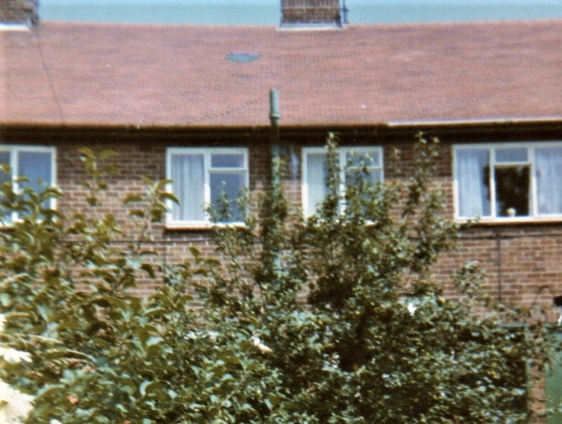
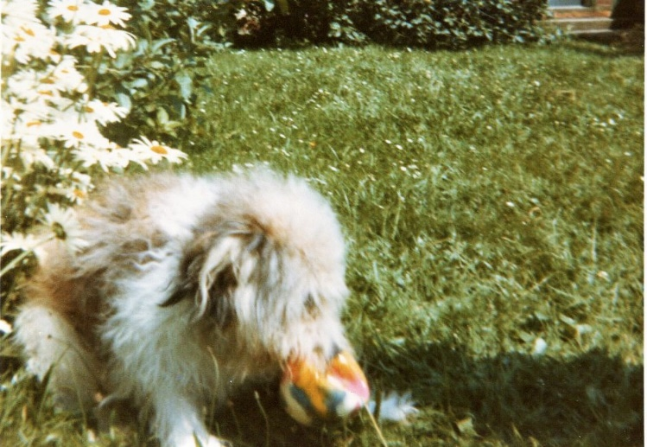
Kay Curtis:
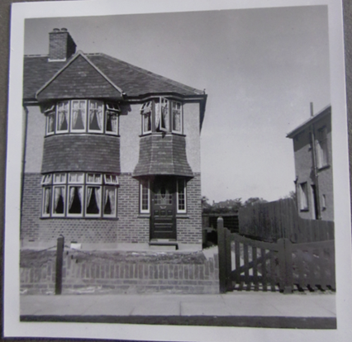
27 Woodlands Avenue
I was born in my parent’s first home, in Eastcote - an area in the London borough of Hillingdon (Boris Johnson’s constituency!) It is in northwest London in the county of Middlesex. Our house at 27 Woodlands Avenue was built in 1938 by the building company Wimpey, part of a new housing estate to accommodate families moving out of London.
The house was a 2-storey semi-detached built of brick. When you went in the front door there was a door on the left going into a living room (lounge) at the front of the house, whilst the hallway led past the stairs to a small dining area and kitchen. Upstairs were 2 large and 1 small bedroom (mine), bathroom with washbasin and bath, and separate toilet. Access to the garden was via the kitchen, and there was a coal bunker just outside against the wall on the right. We did not have a refrigerator – food was kept cool in a cupboard with an air grate at the back – and the cooker was gas-fuelled.
Our back garden had several fruit trees and a wooden compost bin but not much room for vegetables to be grown, and I can remember my Dad on a Sunday putting his gardening tools in the wheelbarrow and walking for 5 minutes to the communal allotment.
Behind the back garden was an open area designated for a primary school, which I eventually went to from the age of five when the building finished – luckily we backed on to the playing fields and not the school buildings.
Woodlands Avenue was paved in large stones, and the neighbourhood kids played hopscotch on them. They were also good for roller skating, and later pogo sticks which my brother and I were given for Christmas. Just two blocks away down the road was a playground with slides and swing where kids from all around the estate could meet up.

Erena:
My family home was built of concrete in the ArtDeco style in the 1940’s, with a flat corrugated iron roof. Concrete steps, painted deep red, lead up to the front door, which was kept open with a heavy iron.

Our half-acre was flat with only one section between us and Orewa beach. There were high fences and hedges to the north and east offering some protection, but the prevailing easterly wind could still blow in. We had a storm door fitted to our back door and windows needed to be secured to prevent the stays being ripped out. Washing would sometimes smell of salt and towels felt slightly sticky from the salt.

The kitchen was a long rectangle shape. It was lined with tall cupboards on one side, and a huge double-door refrigerator with long vertical handles (Prestcold I think) on the other. Then came a small formica table, a stove, sink and bench, and under the kitchen windows was a set of three 1950’s green painted tilting bins.

The house had had a significant addition built in the early 1950’s. The open rear verandha facing east- towards the beach - was replaced with an enclosed sunroom running the length of it. This extension was clad in fibrolite so it always looked like an add-on, but the laundry and toilet were now accessible from inside the house. Mum had a Bendix washing machine, a front loader which must have been very modern. The sunroom had windows and a wide sill all along both outside walls and was a real sun (and fly) trap. The hall, and my mother and brother’s bedrooms opened onto the sunroom with only heavy dark maroon curtains providing privacy.

I am the youngest of three children, and for my first six years of life I shared a bedroom with my sister, 11 years my senior. When she left for Training College I finally had my own bedroom.

The living room was small so the sunroom gave a large additional space. Sometime in the 1960’s after both my siblings left home, the wall shared between my bedroom and the living room was removed. The outside wall facing north was opened up and a ranch slider fitted which greatly lightened the room. A free standing woodburner was installed and we also had an electric Conray heater (with imitation wood surround). I remember a kerosene heater being used before then, with the half-gallon bottles filled with kerosene tipped upside down to feed the heater.

Ken Allan:
Telephones were a dream! It was not just the matter of going down to the local Telecom shop and purchasing a new cellphone and having instant access to the rest of the World, let alone being able to actually make a phone call!
We didn’t have a telephone until about 1954/5. The installation of the new phone was a big occasion for our household. The local Post & Telegraph man came into the kitchen and wired up the black telephone and then announced that we had the “privilege” of making just two phone calls and then we would have to wait six weeks before authorisation would come through from the Post Office in Wellington to use it. We phoned Grandma Allan, who already had a phone installed, and then we rang Dad at work. Conversations over and the handset was placed back on the cradle for six weeks. Why? The telephone still worked but apparently it took the Post Office six weeks to process the paperwork!

Marie Latta:
My first house was a wooden house with large sash windows and the front door was in the middle. The house was close to the wire fence with no room for a lawn or garden.

The 2 front rooms facing the road were a lounge, with a large fire-place and opposite Mum and Dads bedroom which had large wardrobes. Another 2 bedrooms were further down the passage which led into the kitchen scullery and bathroom. Out the back was a brick add-on which had the wash house and coal shed.

Very little room in the backyard with no veggie garden but a long washing line.

Alison Brown:
I was brought up on two different farms in South Otago, about 8kms apart. I do not remember the first house as we shifted when I was about 3. The second place was where my father had moved to when he was 12 and he bought it when my grandparents retired.
The house was built in the 1880s and was a double gabled villa with a big gully trap down the middle. The passage way was long enough to play cricket down it. Possums slid down the roof and when it snowed it occasionally leaked in the gully trap. The house had 6 huge rooms, a scullery, a bathroom and a ‘maid’s’ room which was used as a bedroom. The ceilings were 14 foot high and my bedroom must have been about 4-5 metres square.
My parents made some changes after we got electricity. The toilet was no longer out the back door and down along a path to a long drop in the hedge. It was at the end of an addition which comprised a store room, a laundry and then the toilet. Previously the laundry was done in a separate building with a big copper and wooden wringer. My sister says this building was also for the gardener to live in. I assume this was for the original owner.
The house certainly had had a beautiful garden but my parents were unable to sustain this and the big macrocarpa hedge disappeared along with a number of garden beds. I remember the big monkey puzzle tree and orchard that were there originally.
The two photos may give an indication of what I talked about. The first shows the front of the house before any changes were made and the second is a coloured and touched up photo of the house more like I remember it.
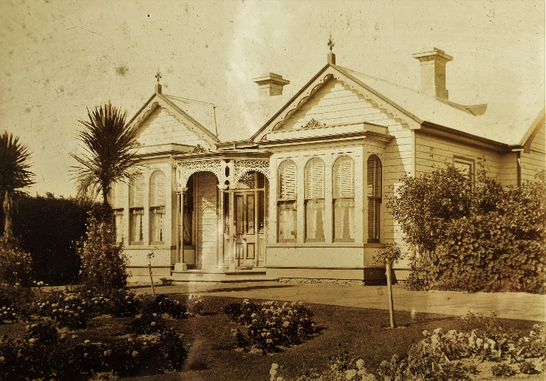 Mt Pleasant original
Mt Pleasant 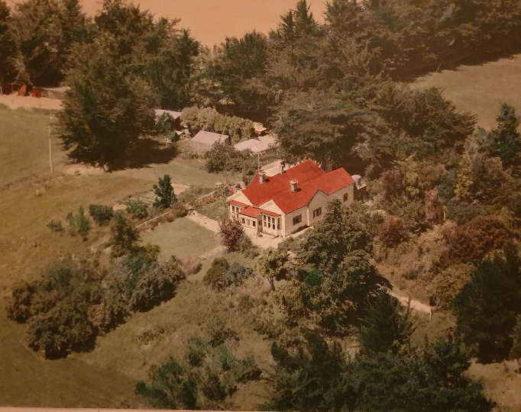

John Wedlake:
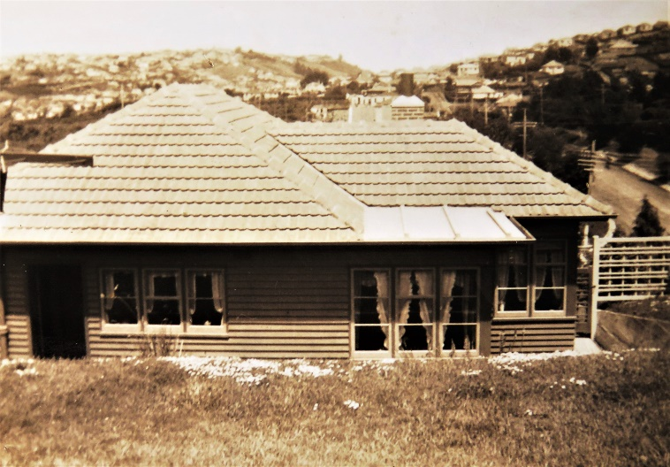
80 Lynn St Dunedin
The house that I grew up in in Dunedin was a two-bedroom, white weather board state house with a concrete tiled roof, built in 1939. (Note that the picture above shows the house when first built and appears as a darker colour). The house was originally rented from the government by my Grand Father William and Grand Mother Ruth (the Winders) and their daughter Ruth Amy Winder.
My mother Ruth lived there with her mum and dad. When her parents died Ruth continued to live there by taking in a boarder for company and to help with the rent. When my parents, Ruth & Jim married in 1953 they continued living there. At some point they changed the ownership arrangement from straight renting to a “rent to own” scheme that was offered by the State Advances Corporation and in the 1960s they became the proud owners.
Our house was a two-bedroom house that like most state houses of the time originally had a wash house at the back. The wash house incorporated a copper, a set of concrete tubs and a wringer washing machine. There was a coal cupboard in the entrance porch at the back door. The kitchen had a green gas cooker incorporating an oven with curled ornate legs. I remember that oven quite clearly the day JFK was assassinated because I was in the kitchen when mum was baking with the radio on. Mum was always baking, often chocolate cake that I helped to mixed and then licked the bowl and beater clean.
The original open fire in the lounge had been replaced with a gas fireplace and so the coal cupboard was no longer required. Sometime in the 1960s Ruth & Jim had the laundry and coal cupboard removed and extended the kitchen to make a large kitchen/dining room. One end of the new kitchen accommodated a new automatic washing machine and a stainless-steel tub. The washing machine was a vertical spin design (front loader) and needed to be bolted to the floor to prevent it “walking around” when spinning. It was my job to periodically go under the house and tighten the bolts. The new kitchen included a split-level gas cook top and alongside that an “eye level” gas oven. For several years we had a red transistor radio that sat on the bench in the kitchen and it was always on 4ZB at breakfast time.
The house originally had no insulation and on cold winter mornings the condensation on the inside of the windows turned to ice. Mum was fanatical about wiping the condensation from the windows every day and “airing” the house by opening the fan light windows in each room. When I was about 10 years old Dad decided to put pink batts in the ceiling. He bought the batts and he and I installed them via the manhole in the hall ceiling. I had to get them into the shallow sloping parts of the roof where dad couldn’t reach. The glass fibres were merciless on my hands and face and itched for days afterwards.
I remember watching southerly weather changes coming up the Kaikorai Valley towards the house from the window in mum & dads’ bedroom. Sometimes hail would come with the cold front and smash against the windowpanes.
The house had a “sunroom” which before the kitchen was enlarged served as the dining room. It had a door off the kitchen and another from the lounge. This room became my bedroom around the time I went to intermediate school. Previously my sister and I had bunks in the single bedroom which became her room when I moved.

Judy Thompson:

Houses We Lived in?
My parents married in 1954 in Caversham Presbyterian Church, Dunedin. They both grew up in Ings Avenue, in St Clair then when newly married had a flat in St Clair until purchasing their first home in Taieri Road, Wakari. They moved in about a month before I was born.
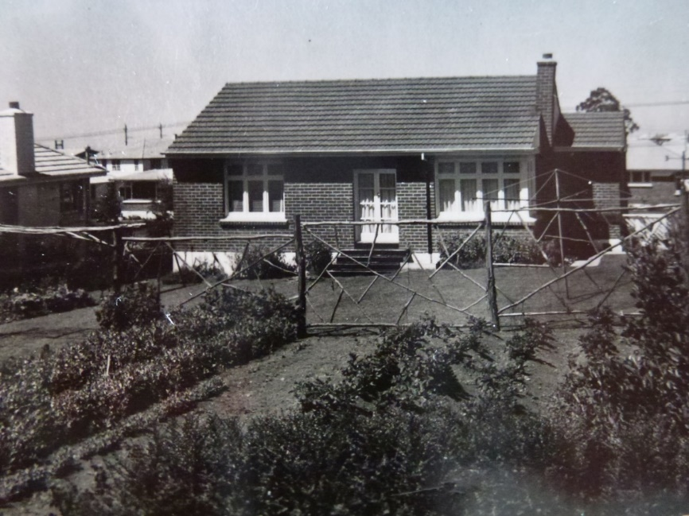
Fences and gates to keep the family away from a busy Taieri Road, the coal bin and a workshop were added in later pictures. The essential rotary clothes line was in the lawn out the back. It was while we lived there the three of us were born. I don’t recall my brother’s arrival, but my recollection of my younger sister’s arrival is that we were sent to stay with ‘Miss Booth’ while Mum was in hospital. I think for possibly 2 weeks as that was the length of hospital stays at that time. I can remember being somewhat disappointed with our new sibling when she arrived home as she was much too small to play with?
The house was a brick and tile home. It was quite small, with 3 bedrooms, a lounge, kitchen, and laundry. It is still there today with the only obvious external change is the addition of a single garage at the front of the section.
There was a large vegetable garden at the back. It was separated from a lawn and the house by a manuka fence. This was quite high but I remember climbing up it and sitting at the top and rocking it back and forwards. Somehow, I don’t think that would have been approved of?
Wakari was of sufficient elevation to receive regular falls of snow. Dad made us sleds and we had a lot of fun on those. We lived near Wakari Hospital which had a large sloping grassy area just perfect for the sled. We spent many a winters day riding the sled and rolling snow balls to make snowmen.
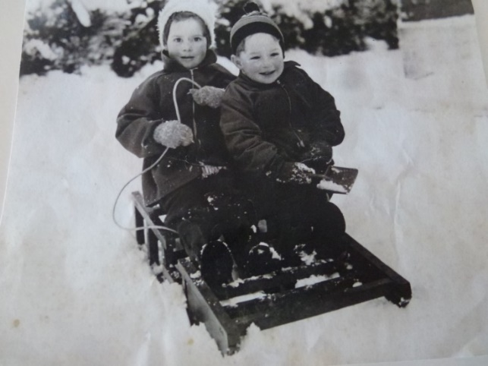
Several ‘incidents’ occurred at that house that I remember. My bedroom was on the eastern corner of the house. It had a window facing Taieri Road. The house had a high foundation on that side. One evening Mum answered the door and a passing motorist had stopped to tell her that a child (me) was hanging out the window!! I had obviously thought I’d climb out the window – forgetting how high the window was above the ground so I was hanging onto the window sill not quite able to pull myself back in.
That same bedroom had very pretty wallpaper with cartoon characters- snow white etc. I remember tearing off the wallpaper…trying to get a complete picture without any rips. I must have been a delightful child!
When I was old enough I was given Mums china faced doll ‘Rosemary’. All was fine until I had an unfortunate fall while carrying her with disastrous consequences. Not even a visit to the ‘Dolly’ Hospital in town where she was taken by the ambulance into the back of the shop, could make her better.
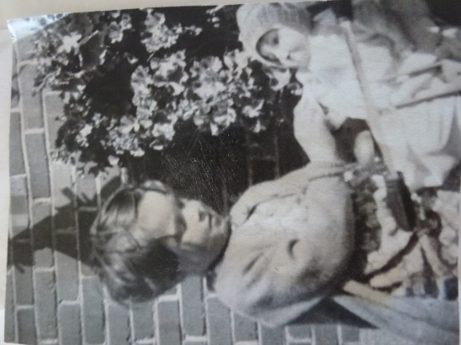
I don’t remember when we moved from Taieri Road, but I do recall starting school at Wakari Primary School in Helensburgh Road.
There was a large coal bin just beside the back door. I recall watching the ‘coal men’ carrying the coal in jute sacks on their backs up the path from the truck. Their back/shoulders were protected by a black leather cape. They would swing the full bag off their shoulder and tip the sack full into the bin all in one smooth movement. Shake the sack and return to the truck laden with sacks of coal for delivery. The coal was really shiny and had a wonderful ‘smell’and was called Ohai coal. My Grandfather used to own “McFarlanes Coal Company”. The delivery base was located in town on the harbour side of Cadbury’s. The original building only recently being demolished to make way for Dunedin’s new hospital. They had their own railway extension line to bring the coal right into the yard from where it was mined in Southland. Dad’s father had died before we were born but I presume Dad still had contacts in the business. Mum used to say she often found me sitting playing in the coal bin, and sometimes eating it!!
While we lived at Taieri Road I can remember Dad was studying a lot in the evenings and weekends to complete his accountancy degree. It must have been a challenge for him and Mum as he worked full time and with three young children to keep quiet. Mum would take us out and entertain us when peace and quiet was necessary.
During the period at Taieri Rd Mum and Dad purchased a section in a new subdivision in Waverley. We were moving to the “sunny peninsula” with a wonderful view of the city and surrounding hills. The purchase must have been about 1960 as photos taken of the tree covered section are labelled with that date. The section would have been approximately an acre in size. The trees were cleared by Dad and the section subdivided into 4 building sites. Our one was the lower section on the corner of Challis and Glengyle Streets. It was a wonderful family home but unfortunately destroyed by a house fire in 2020.
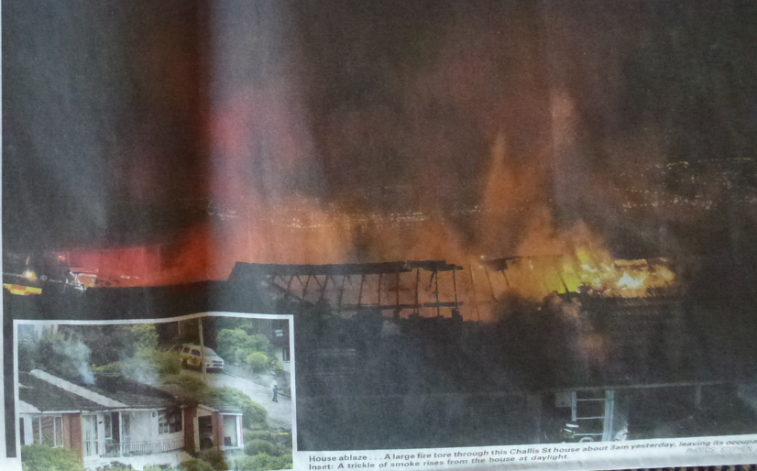

Lesly Stewart
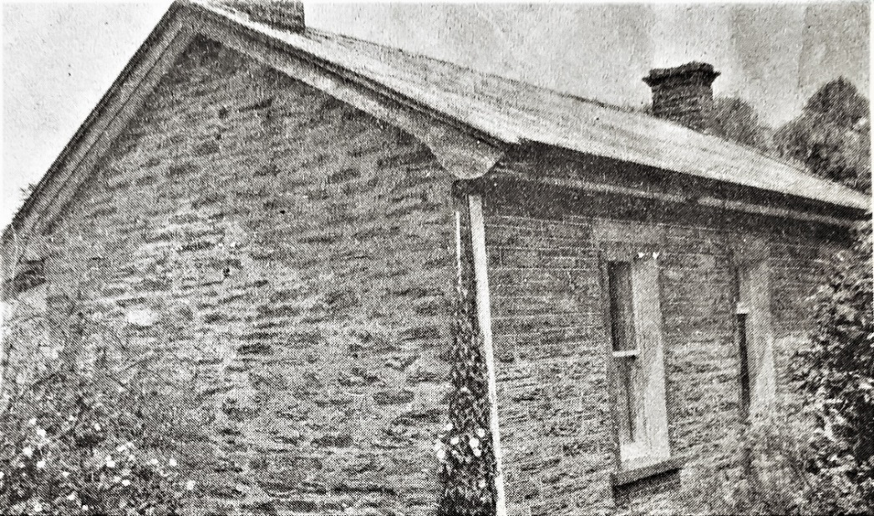

McNeill’s cottage

This House is in 14 Church St Queenstown, Behind Eichardt’s Hotel. It was my first home until 1958
It is one of many stone homes in the central of town left standing and has been a variety of eateries and cafes over the years
It was built in 1885 By Scottish stonemason James McNeill, who also bult the bridge going into the town and the Old Council offices, next to the two big Wellingtonian trees
It was Two half bedrooms, lounge kitchen/dining area and scullery, washhouse facilities were outside, and we only had a copper and mangle and concrete tub, this was all attached to a coal shed.
My younger brother and I shared a room
An older brother slept in a tent outside in a sheltered area
Dad had huge vegie garden and Flower Garden, we kept chooks and did not have a great deal of money, but straight after the war everyone was in the same predicament
Dad was a bridge builder with lakes County council, Mum took in occasional boarders to make ends meet.
Clothes for us all were cut down from other people’s off casts
We had an idyllic life as young folk, Queenstown was a very different place than now, with the population being very much smaller

Magazines and Library
Our library books will be returning to our library shelves on Friday 18 March.

Our magazine committee have once again done a great job of indexing our photos. This makes it easy for you to find where a particular topic you are researching can be found amongst the excellent articles printed in the magazines given to us by Sue Sweet.

An example is this one, to do with dating family photographs, from the Devon Family Historian:

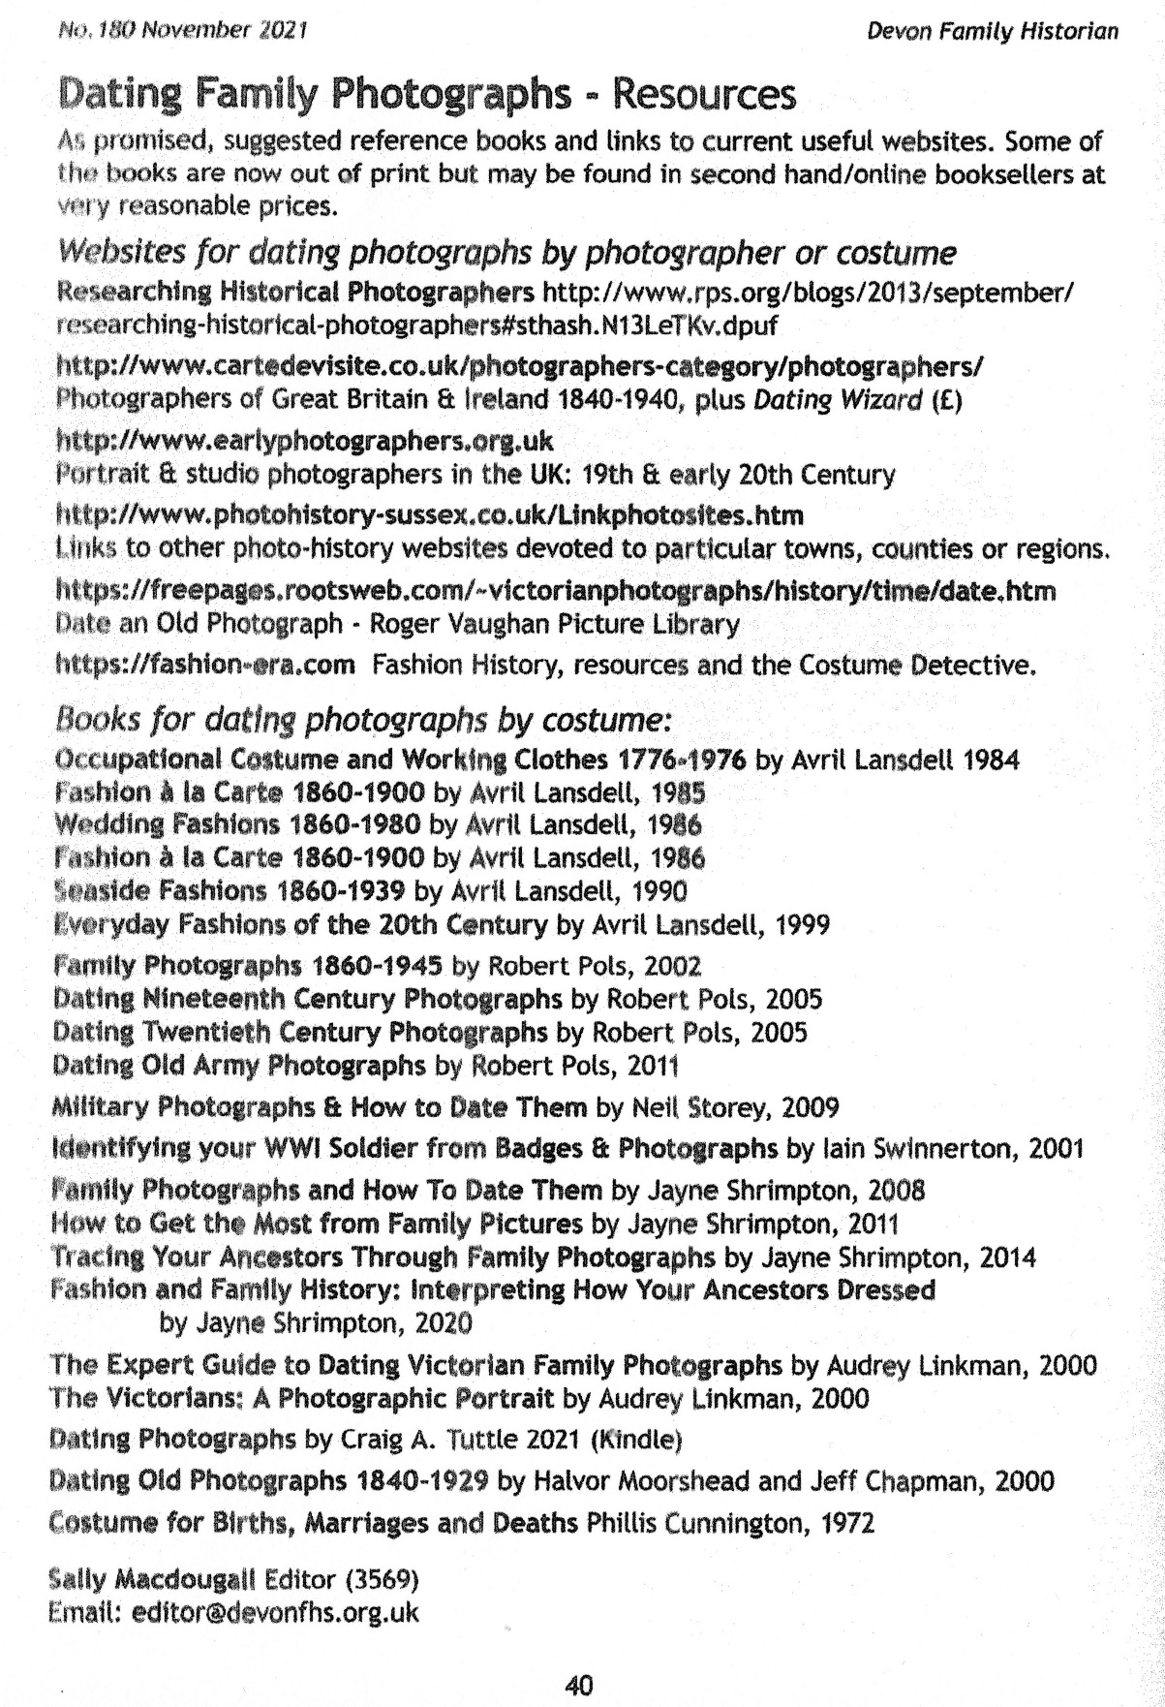
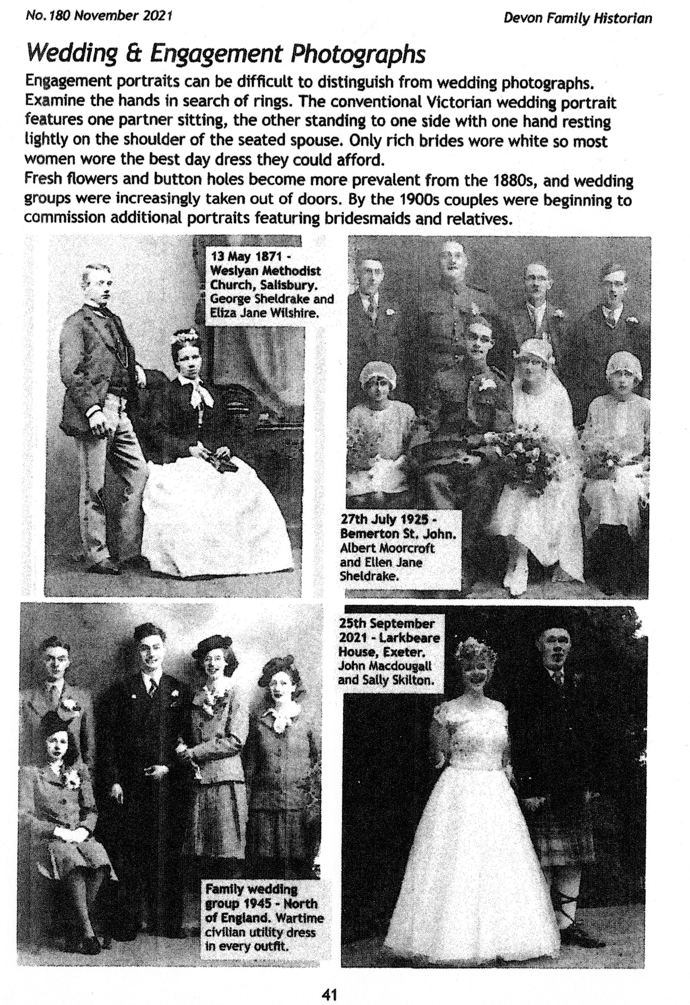

WANAKA GENEALOGICAL GROUP |  | MAGAZINE LIST 2021
TOPIC | CATEGORY | TITLE | MAGAZINE | MONTH
ACTORS | BRITAIN | Ancestors at Work | WDY | Aug
ADOPTION | BRITAIN | Focus on adoption | WDY | Feb
AGRICULTURAL LABOURERS | OCCUPATIONS | My ancestors were agricultural labourers - or were they | FT | April
AGRICULTURAL LABOURERS | OCCUPATIONS | Agricultural labourers | WDY | June
ANCESTRY | "ANCESTRY" | Master class - Building online "Ancestry" tree | FT | Jan
ARMED FORCES |  | Tracing Family in the Forces | FT | Nov
ARMED FORCES |  | Courts Martial | WDY | Nov
AUSTRALIA | AUSTRALIA | Tracing ancestors in Australia | WDY | March
AUSTRALIA | AUSTRALIA | Best websites to trace ancestors | WDY | April
BELLS | BRITAIN | Bell inscription books, 1888-2005 | WDY | March
BERKSHIRE | BRITAIN | Around Britain | WDY | Aug
BRICKMAKERS | OCCUPATION | Brickmakers | WDY | Oct
BURIALS | BRITAIN | Strange burials, graves etc. | FT | June
CANADA | CANADA | Canadian war brides | WDY | July
CANADA | CANADA | Canadian Censuses | WDY | Aug
CANAL BOATS | BRITAIN | Canal Boat Families | WDY | Oct
CARPENTERS | OCCUPATIONS | Ancestors at work | WDY | Feb
CARIBBEAN |  | Caribbean Genealogy | FT | Oct
CEMETERIES | BRITAIN | Highgate Cemetery, London | FT | Dec
CENSUS | CENSUS | The Census 1811 | WDY | Jan
CENSUS | CENSUS | The Census 1821 | WDY | Feb
CENSUS | CENSUS | The Census 1831 | WDY | March
CENSUS | CENSUS | The Census 1841 | WDY | April
CENSUS | CENSUS | The Census 1851 | WDY | May
CENSUS | CENSUS | The Census 1861 | WDY | June
CENSUS | CENSUS | The Census 1871 | WDY | July
CENSUS | CENSUS | The Census 1891 | WDY | Aug
CENSUS | CENSUS | The Census 1901 | WDY | Sept
CHELSEA PENSIONERS | LONDON | Service records websites | WDY | July
CHILDREN'S HOMES | BRITAIN | Children in care | WDY | April
CLERKS | OCCUPATIONS | Ancestors at work | WDY | May
CLOTHING |  | Clothing worn in Institutions | FT | March
CLOTHING |  | Rationed fashion - WW2 clothes rationing | FT | June
COASTAL TRADES | OCCUPATIONS | Tracing the coastal trades | FT | Feb
COVENTRY | BRITAIN | Coventry motor city | WDY | June
CRICKET | SPORT | Cricket ancestors | FT | April
CRIME | BRITAIN | Criminal records | FT | Jan
CUMBERLAND | BRITAIN | Around Britain | WDY | Sept
CUTLER | OCCUPATION | At the Cutting Edge | WDY | Nov
DAIRY WORKER | OCCUPATIONS | The demand for Dairy | WDY | Feb
DISEASES |  | Covid v. Cholera | FT | July
DNA | DNA | DNA Workshop | FT | Jan
DNA | DNA | DNA Workshop | FT | Feb
DNA | DNA | DNA Workshop | FT | March
DNA | DNA | Discovering DNA / DNA Workshop | FT | April
DNA | DNA | DNA Workshop | FT | May
DNA | DNA | Maximise your DNA research on Ancestry | FT | May
DNA | DNA | DNA sleuth | FT | July
DNA | DNA | DNA Workshop | FT | July
DNA | DNA | Your DNA Workshop | FT | Aug
DNA | DNA | DNA Boot Camp Tips | FT | Aug
DNA | DNA | Your DNA Workshop | FT | Sept
DNA | DNA | Your DNA Workshop | FT | Oct
DNA | DNA | Enlisting DNA on your family history quest | FT | Nov
DNA | DNA | Your DNA Workshop | FT | Dec
DOOMSDAY BOOK | BRITAIN | Tracing family back to Doomsday Book | WDY | July
DUMFRIES & GALLOWAY | SCOTLAND | Around Britain records | WDY | July
ECONOMICS | BRITAIN | The Economic Impact on Families c.1650's-1750's | FT | Sept
EDWARDIAN ERA |  | The First Edwardians - Medieval History | FT | July
FAMILY HISTORIAN | SOFTWARE | Family Historian 7 | WDY | March
FAMILY HISTORIAN | SOFTWARE | Family Historian 7 | FT | March
FAMILY HISTORY |  | Sharing your family history online | FT | Feb
FAMILY HISTORY | FHS | The Family, Community Historical Research Society | FT | April
FAMILY HISTORY | FHS | Weston-Super-Mare & District FHS | FT | Sept
FAMILY HISTORY | FHS | Oxfordshire FHS | FT | Oct
FAMILY HISTORY | BRITAIN | Spotlight on Cumbria | FT | Nov
FAMILY HISTORY | FHS | The Borders FHS | FT | Dec
FAMILY SEARCH | WEBSITE | 20 Things you need to know about Family Search | FT | Aug
FAMILY TREES | SOFTWARE | Family trees online | WDY | June
FILM | BRITAIN | How Cinema boosted morale on the Home Front | WDY | Nov
FISHERMEN | OCCUPATIONS | Netting your ancestors | FT | March
FISHERMEN | OCCUPATIONS | Fishing and Whaling websites | WDY | July
FORUMS | WEBSITE | Best Websites | WDY | Aug
FREEMASONS |  | Freemasonry | WDY | March
GARDENER | OCCUPATIONS | Gardeners' register 1822-1829 | WDY | June
GIBRALTAR | GIBRALTAR | Focus - Uncover your Roots | WDY | April
GOVERNESSES | OCCUPATION | Ancestors at Work | WDY | Sept
GREAT WAR | WAR | Prisoners of the Great War | FT | Sept
HAMPSHIRE | BRITAIN | Around Britain - Hampshire | WDY | March
HATTERS |  | Felt hatters | WDY | July
HERALDRY |  | Heraldry - your get-started guide | FT | May
HEREFORDSHIRE | BRITAIN | Around Britain - Herefordshire | WDY | Jan
HOME FRONT | BRITAIN | Home Guard records | WDY | June
HOSPITALS |  | Hospital records | WDY | July
HOUSE HISTORIES | BRITAIN | Searching the History of Houses | FT | June
HOUSE HISTORY | BRITAIN | How to trace history of your Ancestor's homes | FT | Oct
HOUSE HISTORY |  | How to keep your House History organised | FT | Oct
HOUSE HISTORY |  | "A House through Time" | FT | Oct
INDIA | INDIA | How to find your missing family in India | FT | Sept
INSTITUTIONS |  | Clothing worn in Institutions | FT | March
IRELAND | IRELAND | Irish Wills from 1858 | WDY | Jan
IRELAND | WEBSITES | Irish research websites | WDY | Feb
IRELAND | IRELAND | Using Local Archives & Libraries | FT | March
IRELAND | IRELAND | Irish Tithe Applotment Books | WDY | April
IRELAND | IRELAND | Life in Limerick | FT | July
IRELAND | IRELAND | Irish Petty Sessions | WDY | Sept
IRELAND | IRELAND | Ireland Prison Records on Family Search | FT | Oct
IRELAND | IRELAND | Irish Land Records | FT | Nov
ITALY | ITALY | A natural disaster - the Messina Earthquake | FT | Nov
JEWISH ANCESTRY | WEBSITES | The Holocaust, best websites | WDY | Jan
LONDON | BRITAIN | London online | WDY | Oct
MAPS | BRITAIN | Uncover 19th century parish boundaries | WDY | June
MAPS |  | Mapping our ancestors' lives | FT | Oct
MARRIAGE |  | Marriage Licences - Masterclass | WDY | May
MARRIAGE |  | Love and marriage | WDY | June
MEDICAL | BRITAIN | Medical Officer of Health Reports | WDY | Feb
MEDICAL |  | Ships' doctors | FT | June
MEDIEVAL GENEALOGY | FRANCE | Household account book 1431-1432, Rouen Castle |  | pre-June
MERCHANT NAVY | OCCUPATION | The Victorian Merchant Navy | WDY | Sept
MIDLANDS | BRITAIN | Midlands Ancestors | FT | March
MIGRATION | WEBSITES | Migration websites | WDY | Dec
MILITARY HISTORY | BRITAIN | Muster Rolls and the Militia | WDY | March
MILITARY HISTORY | BRITAIN | 19th century Army Service Records | FT | June
MILITARY HISTORY | BRITAIN | Royal Victoria Military Hospital | FT | Nov
NAIL-MAKERS | OCCUPATIONS | Ancestors at work | WDY | March
NAMES |  | Guide to One-Name Studies | WDY | March
NAMES |  | Changing surnames - a guide to surname research | FT | April
NAMES |  | The History of Surnames | WDY | Sept
NEWSPAPERS |  | Best websites for newspapers | WDY | May
NON-CONFORMIST RECORDS |  | Non-conformists | WDY | Oct
NORFOLK | BRITAIN | Norfolk | WDY | June
NORTHUMBERLAND | BRITAIN | Berwick Bridge account book 1611-1614 | WDY | Sept
ONLINE GENEALOGICAL INDEX | WEBSITE | OGI free-to-use database - England, Wales, Isle of Man | FT | Aug
OXFORDSHIRE | BRITAIN | Around Britain, Oxfordshire | WDY | Nov
PACKET SHIPS, POST OFFICE | SHIPPING | By Sail & Steam, life aboard | WDY | Aug
PARISH RECORDS | "ANCESTRY" | Exploring Parish Registers on "Ancestry" | FT | Jan
PARISH RECORDS | BRITAIN | Parish registers - 5 centuries of family history | FT | Feb
PARISH RECORDS | BRITAIN | English and Welsh Baptism Registers | WDY | March
PARISH RECORDS | BRITAIN | Parish registers online | WDY | July
PARISH RECORDS | BRITAIN | Parish and Non-Conformist Registers on Freereg.org.uk | WDY | Nov
PHOTOS |  | How to safeguard your old family photographs | WDY | Jan
PHOTOS | "MY HERITAGE" | Photo sharpening with "My Heritage" | WDY | Jan
PHOTOS |  | Vivid-Pix Restore, step-by-step | FT | Nov
POLICE | WEST MIDLANDS | West Midlands police and criminal records | WDY | Jan
POLICE | BRITAIN | West Midlands Police Museum | WDY | Oct
POLICE | BRITAIN | The Police - best websites | WDY | June
POLICEWOMEN | OCCUPATIONS | Policewomen | WDY | Jan
POSTAL WORKERS | OCCUPATIONS | Post Office appointment books | FT | Feb
POSTCARDS |  | Researching postcards | WDY | Oct
PRISONS |  | Prison Records | WDY | Nov
PRISONERS OF WAR | WW1/WW2 | Escapes from WW1 POW camps in Britain, 1914-1920 | FT | July
RAILWAYS | BRITAIN | Going off the rails - Victorian ancestors' railway mania | WDY | Jan
PUBLICAN | OCCUPATIONS | Victuallers' licences | WDY | Jan
PUBLISHING |  | How to Produce a printed Photo Book | WDY | Aug
QUAKERS | BRITAIN | Helping Britain's German Community in WW1 | WDY | Sept
RESEARCH | RESEARCH | Good research strategy | FT | Jan
RESEARCH | RESEARCH | Looking at records thru' different lens | FT | Feb
RESEARCH | 17th CENTURY | 17th Century - Plots, Pikes, Plague and Puritans | WDY | March
RESEARCH | RESEARCH | Skills to progress your family tree | FT | March
RESEARCH | RESEARCH | Finding facts in fiction | FT | April
RESEARCH | RESEARCH | Starting your family history | FT | April
RESEARCH | RESEARCH | Learning about the Records | FT | May
RESEARCH |  | Starting out on your Family Tree - a miniguide | FT | Nov
ROYAL MARINE | OCCUPATIONS | The Royal Marines | WDY | June
ROYAL NAVY | OCCUPATION | Royal Navy Service Records - military history sleuth | FT | Aug
SCHOOL | BRITAIN | School Records - where to search | FT | Dec
SCOTLAND | SCOTLAND | Scottish clergy - online database | WDY | Feb
SCOTLAND | SCOTLAND | Scottish Poor Law records | FT | March
SCOTLAND | SCOTLAND | Key 20th century Scottish Resources | FT | Aug
SCOTLAND | WEBSITE | Best Scottish websites | WDY | Nov
SEASIDE | BRITAIN | Victorian & Edwardian coast holidays | FT | July
SHIPS |  | A home on the waves - tracing a merchant ship | FT | Oct
SILK WORKERS | OCCUPATIONS | Ancestors at work | WDY | April
SOCIAL HISTORY | BRITAIN | The Hidden Rules of Etiquette - Regency era | WDY | March
SOCIAL HISTORY | BRITAIN | Pillow talk | WDY | Oct
SOFTWARE | SOFTWARE | Buyers guide to Family Tree Packages | WDY | April
SOFTWARE | SOFTWARE | SVG Family Tree Generator - free software | FT | Aug
SPORT |  | 19th century Boxing & Wrestling | WDY | July
SPORT |  | Sporting Ancestors | WDY | Aug
STAFFORDSHIRE | BRITAIN | Staffordshire records - websites | WDY | Sept
SUFFRAGE | BRITAIN | A Suffragette's Fight | WDY | Aug
SUFFRAGE | BRITAIN | The Census 1911 | WDY | Oct
TEACHERS | BRITAIN | Teachers' Registers | WDY | Oct
TECHNOLOGY |  | Tech Tips - Locate old and forgotten streets | WDY | April
TECHNOLOGY |  | Tech Tips-how to use "Ancestor Search" to track relatives | WDY | May
TECHNOLOGY | SOFTWARE | Tech Tips - Ancestors' life stories with timelines | WDY | Sept
TECHNOLOGY |  | Tips from the Genealogy Tutors | WDY | Sept
TECHNOLOGY |  | Tech Tips - Put your research in order using Zotero | WDY | Oct
TECHNOLOGY |  | Tech Tips - Read and Transcribe documents | WDY | Nov
TRADE DIRECTORIES | BRITAIN | Focus on Victorian equivalent of the "Yellow Pages" | WDY | Aug
TRADE DIRECTORIES | BRITAIN | Trade Directories - Beginners Guide | FT | Aug
TYNE AND WEAR | BRITAIN | Around Britain - Tyne & Wear | WDY | Nov
VICTORIAN PERIOD | BRITAIN | Victorian ancestors' railway mania | WDY | Jan
VOTING | BRITAIN | Poll Books records | WDY | Dec
WALES | "ANCESTRY" | Welsh records on "Ancestry" | WDY | Jan
WALES | BRITAIN | Around Britain - North-east Wales | WDY | May
WALES | BRITAIN | Welsh tithe maps | WDY | June
WALES | BRITAIN | Wales - best websites | WDY | Sept
WEBSITES |  | 50 websites to watch in 2021 | WDY | Jan
WILLS | WILLS | Wills before 1858 | FT | Jan
WILLS | WILLS | Getting to grips with Wills (England, Wales) | FT | Feb
WILLS | WILLS | What else is there? Probate records | FT | April
WOMEN ANCESTORS |  | How to find stories of the women in your family | FT | March
WORKHOUSES | BRITAIN | A workhouse network venture | FT | May
WORKHOUSES | BRITAIN | Workhouse Infirmaries | WDY | Dec
WRITING |  | Introducing Story Scout - sharing family stories | FT | May
WRITING |  | The principles of writing Ancestor stories | FT | Oct
WRITING |  | Writing family histories - the practicalities | FT | Dec
WRITING |  | Writing family histories - interviewing an Ancestor | FT | Dec
WW1 | WW1 | Mapping Loss: communities in war and peace | WDY | Jan
WW1 | WW1 | WW1 Shipwrecks | FT | June
WW2 | WW2 | Fire brigade disaster | FT | May
YORKSHIRE | YORKSHIRE | A Yorkshire football scrapbook, 1909-95 | WDY | Jan
YORKSHIRE | YORKSHIRE | East Riding - around Britain | WDY | April
"FT" = Family Tree magazine
"WDY" = Who Do You Think You Are magazine

PROGRAMME FROM 25 March to 27 May
Friday 25 March – Trip to Bendigo – Meeting at Bendigo at 11am. Information above.

Monday 4 April – Writing/Techy Tips – Bring along what you are working on.
86 Kings Drive 2pm

Friday 29 April – ANZAC – Sharing the war story of one of your ancestors – Wanaka Library 2pm.

Friday 28 May – AGM – also ‘Dating Photographs’ – Time and place to be confirmed.

Committee
Secretary: Lesly Stewart
Treasurer: Kay Curtis
Erena Barker
Doreen Hale
Louise Primrose
Margaret Thomlinson

Email address - wanarelly@gmail.com
Website - https://wanakagenealogy.weebly.com/

